Bank Loan Query Doc

1. BANK LOAN REPORT | SUMMARY

KPI’S

**Total Loan Applications**

Select count(id) as Total_Loan_Applications

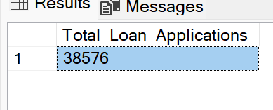from bank_loan_data;

**MTD Loan Applications**

Select count(id) as MTD_Total_Loan_Applications

from bank_loan_data

where month(issue_date) = 12 and year(issue_date) = 2021;

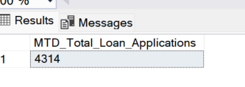

**MTM Loan Applications**

Select count(id) as PMTD_Total_Loan_Applications

from bank_loan_data

where month(issue_date) = 11 and year(issue_date) = 2021;

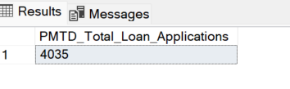

**--Total Funded Amount**

Select sum(loan_amount) as Total_Funded_Amount

from bank_loan_data;

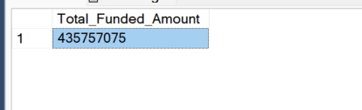

-- **Total Funded Amount ( MOD)**

Select sum(loan_amount) as MTD_Total_Funded_Amount

from bank_loan_data

where month(issue_date) = 12 and year(issue_date) = 2021;

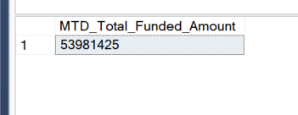

-- **Total Funded Amount ( PMTD)**

Select sum(loan_amount) as PMTD_Total_Funded_Amount

from bank_loan_data

where month(issue_date) = 11 and year(issue_date) = 2021;

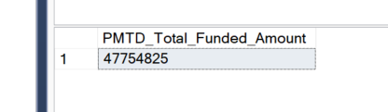

-- **Total Amount Recieved**

Select sum(total_payment) as Total_Amount_Recieved

from bank_loan_data;

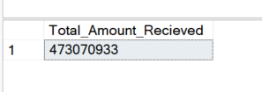

-- Total Amount Recieved (MTD)

Select sum(total_payment) as MTD_Total_Amount_Recieved

from bank_loan_data

WHERE MONTH(issue_date) = 12 and year(issue_date) = 2021;

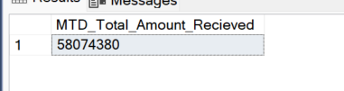

-- Total Amount Recieved (PMTD)

Select sum(total_payment) as PMTD_Total_Amount_Recieved

from bank_loan_data

WHERE MONTH(issue_date) = 11 and year(issue_date) = 2021;

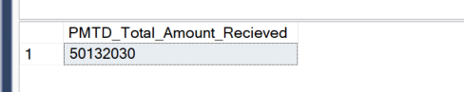

-- Average Interest Rate

USE BankLoanDB;

SELECT ROUND(AVG(int_rate),2) * 100 as Avg_Interest_Rate

from bank_loan_data;

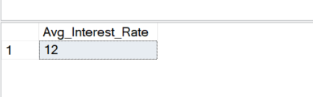

-- MTD Average Interest Rate

SELECT ROUND(AVG(int_rate),4) * 100 as MTD_Avg_Interest_Rate

from bank_loan_data

WHERE MONTH(issue_date) = 12 AND YEAR(issue_date) = 2021;

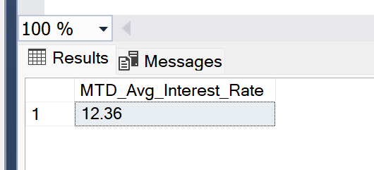

-- PMTD Average Interest Rate

SELECT ROUND(AVG(int_rate),4) * 100 as PMTD_Avg_Interest_Rate

from bank_loan_data

WHERE MONTH(issue_date) = 11 AND YEAR(issue_date) = 2021;

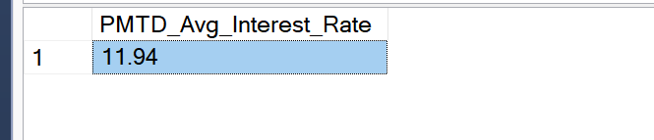

-- Average DTI

SELECT ROUND(AVG(dti),4) * 100 As Avg_DTI from bank_loan_data

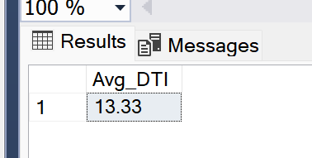

-- MTD Average DTI

SELECT ROUND(AVG(dti),4) * 100 As MTD_Avg_DTI from bank_loan_data

WHERE MONTH(issue_date) = 12 and year (issue_date) = 2021;

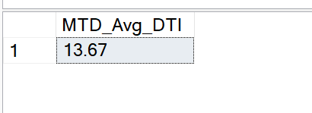

--PMTD Average DTI

SELECT ROUND(AVG(dti),4) * 100 As PMTD_Avg_DTI from bank_loan_data

WHERE MONTH(issue_date) = 11 and year (issue_date) = 2021;

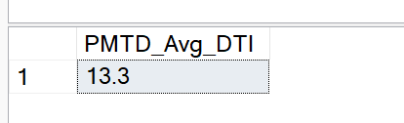

-- GOOD LOAN PERCENTAGE

SELECT

(COUNT( case when loan_status ='Fully Paid' or loan_status = 'Current' then id END)* 100)

/

count(id) as Good_loan_percentage

from bank_loan_data;

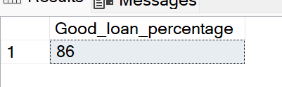

-- GOOD LOAN APPLICATIONS

SELECT COUNT(id) FROM bank_loan_data as Good_loan_applications

where loan_status ='Fully Paid' or loan_status = 'Current';

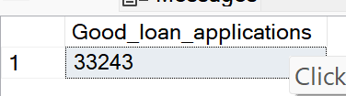

-- Good Loan Funded AMOUNT

SELECT SUM(loan_amount) as Good_loan_funded_Amount FROM bank_loan_data

where loan_status ='Fully Paid' or loan_status = 'Current';

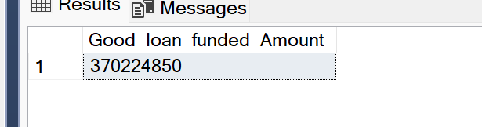

--Good Loan Payment Recieved

SELECT SUM(total_payment) as Good_loan_Total_Payment_Recieved FROM bank_loan_data

where loan_status ='Fully Paid' or loan_status = 'Current';

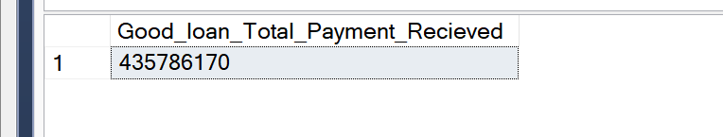

-- BAD LOAN PERCENTAGE

SELECT

(COUNT( case when loan_status = 'Charged off' then id END)* 100)

/

count(id) as Bad_loan_percentage

from bank_loan_data;

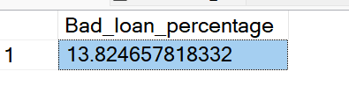

-- BAD LOAN APPLICATIONS

SELECT COUNT(id) FROM bank_loan_data as Bad_loan_applications

where loan_status ='Charged off';

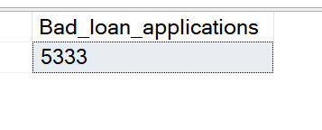

-- Bad Loan Funded AMOUNT

SELECT SUM(loan_amount) as Bad_loan_funded_Amount FROM bank_loan_data

where loan_status ='Charged off'

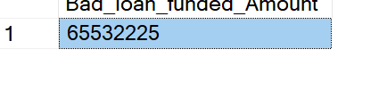

--Bad Loan Payment Recieved

SELECT SUM(total_payment) as Bad_loan_Total_Payment_Recieved FROM bank_loan_data

where loan_status ='Charged off';

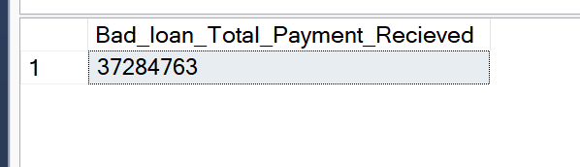

-- Loan Status

Select loan_status, count(id) as Total_Loan_Applications , sum(total_payment) as Total_Amount_Recieved, sum(loan_amount) as Total_Funded_Amount, round(avg(int_rate *100),2) as Interest_Rate, round(avg( dti * 100),2) as DTI

from bank_loan_data

group by loan_status;

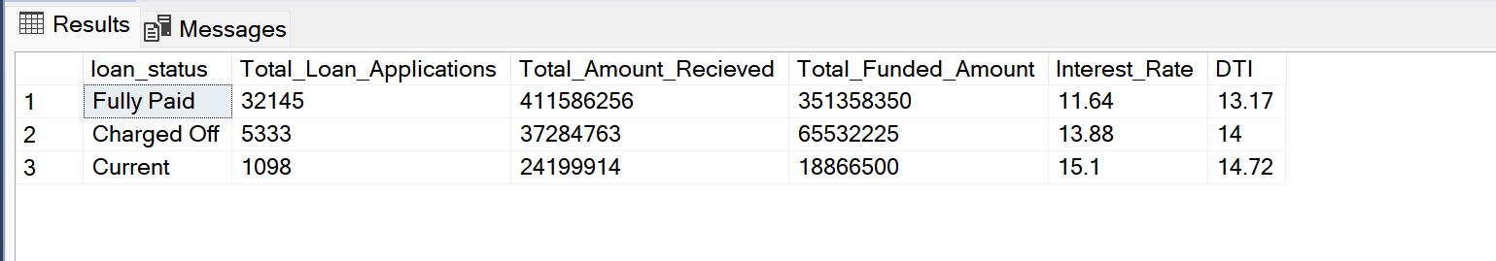

-- Loan Status - MTD

Select loan_status , sum(total_payment) as MTD_Total_Amount_Recieved, sum(loan_amount) as MTD_Total_Funded_Amount

from bank_loan_data

WHERE MONTH(issue_date) = 12

group by loan_status;

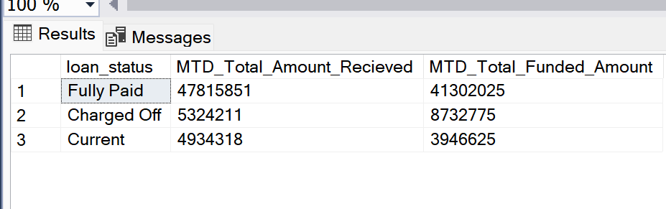

-- 2nd Dashboard

SELECT

MONTH(issue_date) as Month_Num,

DATENAME ( MONTH, issue_date) as Month_Name,

COUNT(id) as Total_Loan_Applications,

SUM(loan_amount) AS Total_Funded_Amount ,

SUM(total_payment) AS Total_Recieved_Amount

from bank_loan_data

Group by MONTH(issue_date),DATENAME ( MONTH, issue_date)

order by MONTH(issue_date) ;

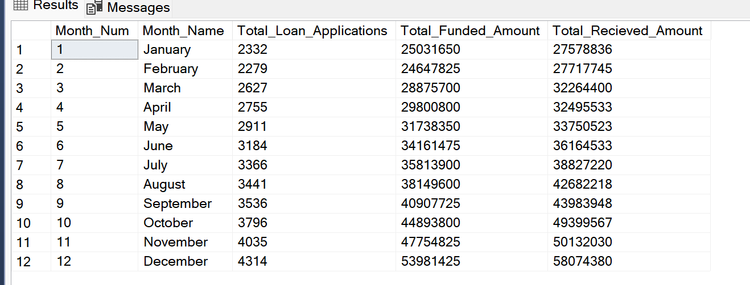

-- Region

SELECT

address_state,

COUNT(id) as Total_Loan_Applications,

SUM(loan_amount) AS Total_Funded_Amount ,

SUM(total_payment) AS Total_Recieved_Amount

from bank_loan_data

Group by address_state

order by SUM(loan_amount) desc;

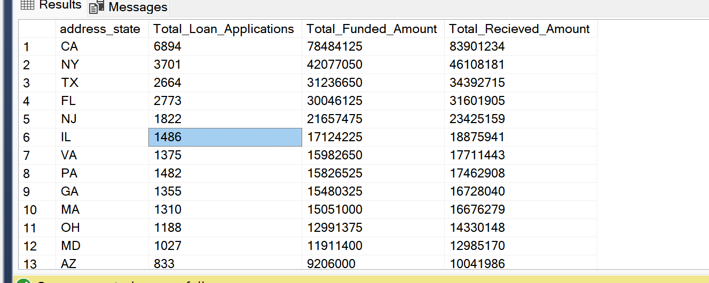

-- Term

SELECT

term,

COUNT(id) as Total_Loan_Applications,

SUM(loan_amount) AS Total_Funded_Amount ,

SUM(total_payment) AS Total_Recieved_Amount

from bank_loan_data

Group by term

order by term;

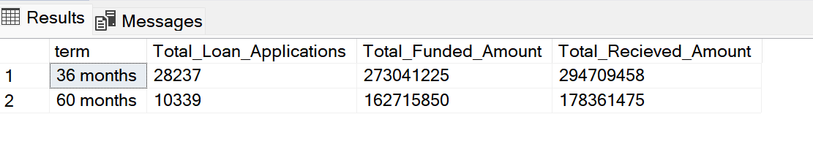

-- Employee-Length

SELECT

emp_length,

COUNT(id) as Total_Loan_Applications,

SUM(loan_amount) AS Total_Funded_Amount ,

SUM(total_payment) AS Total_Recieved_Amount

from bank_loan_data

Group by emp_length

order by count(id)desc;

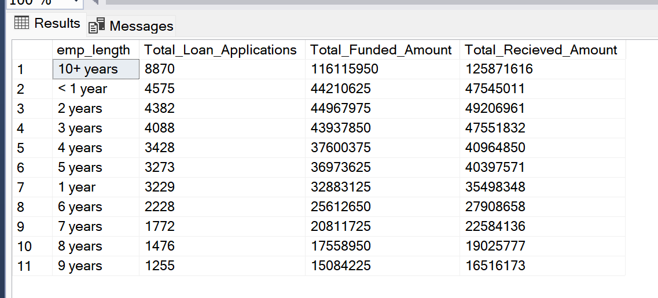

-- Purpose

SELECT

purpose,

COUNT(id) as Total_Loan_Applications,

SUM(loan_amount) AS Total_Funded_Amount ,

SUM(total_payment) AS Total_Recieved_Amount

from bank_loan_data

Group by purpose

order by count(id)desc;

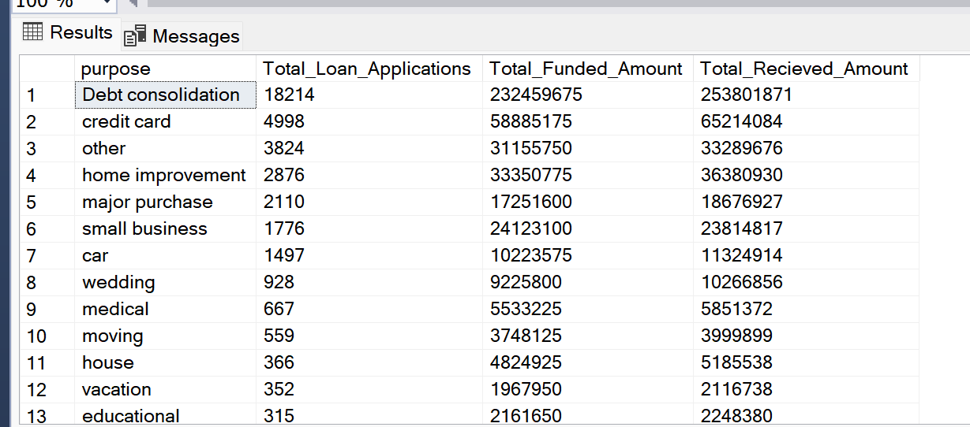

-- Home Ownership

SELECT

home_ownership,

COUNT(id) as Total_Loan_Applications,

SUM(loan_amount) AS Total_Funded_Amount ,

SUM(total_payment) AS Total_Recieved_Amount

from bank_loan_data

Group by home_ownership

order by count(id)desc;

